Table of Contents

Graphs 1

Handshaking Theorem 1

Incidence Matrix 1

Euler Path 1

Euler Circuit: 2

Hamiltonian Path: 2

Hamiltonian Circuit: 2

Trees 2

Transversal: 2

Binomial Theorem 2

Mathematical Induction 4

Set Identities 4

Set Word Problem (Inclusive – Exclusive) 5

Function 6

Propositional Laws 6

Quantifiers 7

Rules of Inference 9

Psuedorandom Numbers 10

UPCs 11

# Graphs

## Handshaking Theorem

The sum of degrees of all the vertices is equal to twice the number of edges in a graph.

In Degree (–): Number of edges coming into the vertex.

Out Degree (+): Number of edges going out of the vertex.

Loops have 1 in and 1 out degree.

## Incidence Matrix

Edges = Column Vertices = Rows

## Euler Path

* Transverse every edge exactly once.
* Starting and Ending point can be different.
* Vertex can be repeated.

## Euler Circuit:

* First and Last vertex is same.
* Transverse every edge exactly once.
* A Graph is Euler graph/path iff it has at most 2 odd degree vertices.
* Euler Circuit 🡪 Each Vertex is of even degree.

## Hamiltonian Path:

* Transverse every vertex exactly once.
* Starting and Ending vertex can be different.
* Edges can be repeated.
* Length = N – 1 edges.

## Hamiltonian Circuit:

* First and Last vertex is same.
* Transverse every vertex exactly once.

# Trees

A node with no children is called a leaf node.

A node with children is called an internal vertex/node.

Nodes having common parent nodes are siblings

Root Node is at level 0

Level = 0,1,2,3,4 = 5 levels.

Height = 4

Max Level = Height

Prefix = R to L

Postfix = L to R

## Transversal:

Preoder: A se start aur ghuuma do puura.

Post Order: Deletion of left leaf.

Inorder: Double Visited Node is written.

# Binomial Theorem

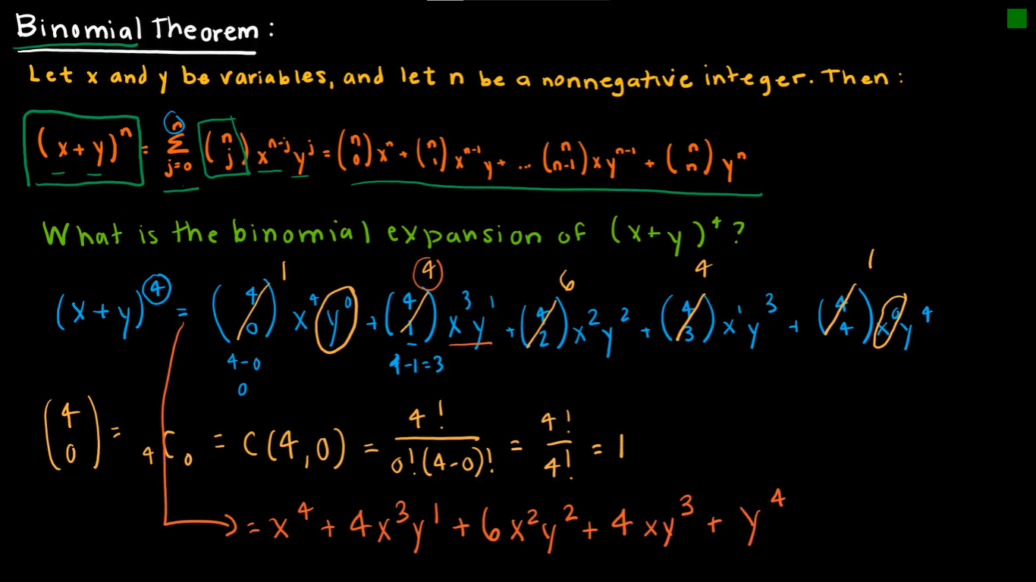

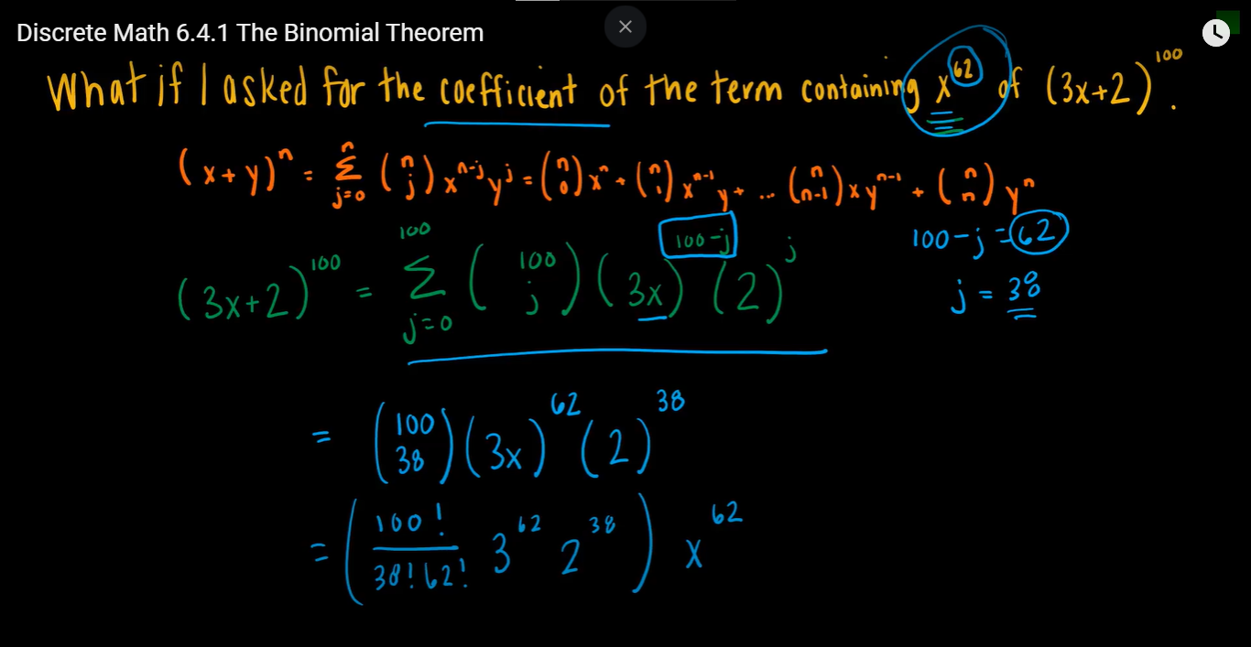

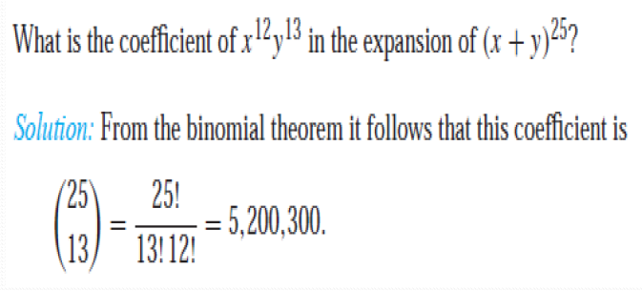

# Mathematical Induction

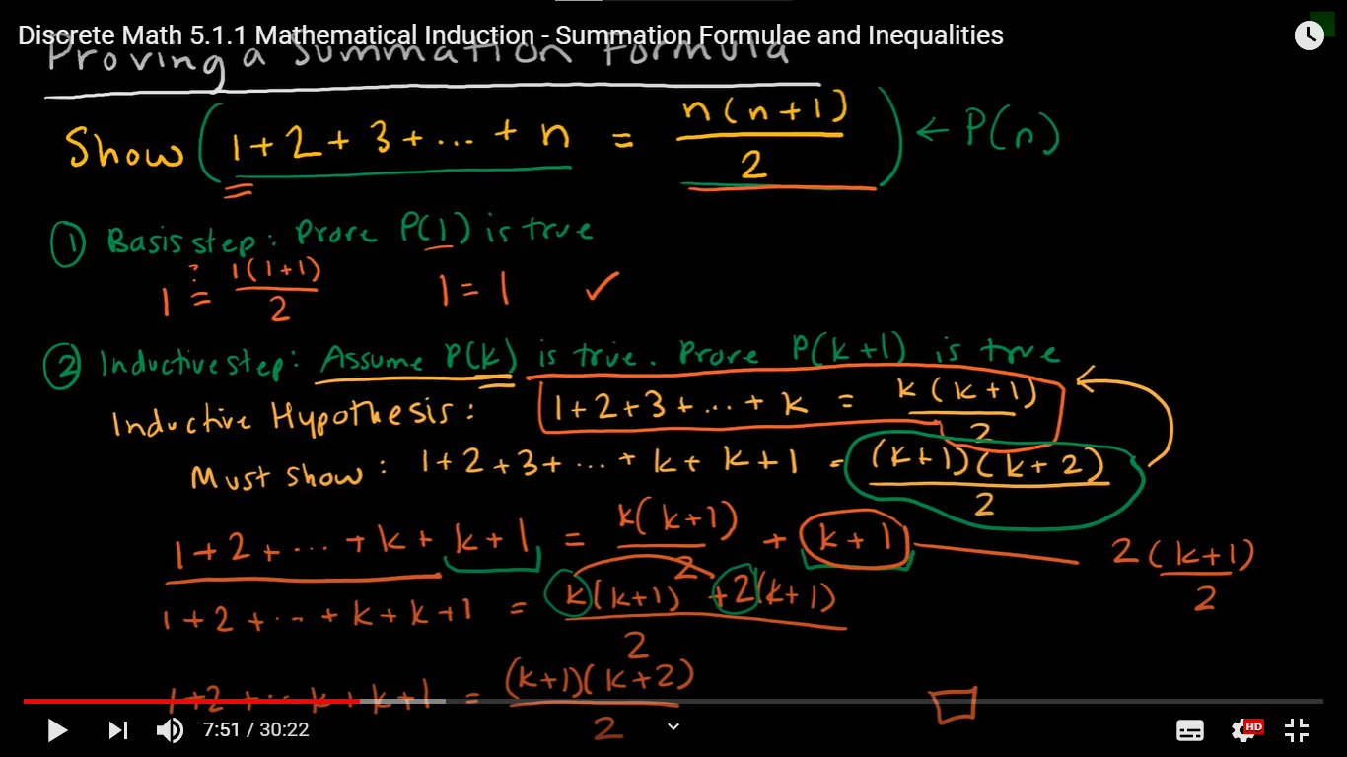

# Set Identities



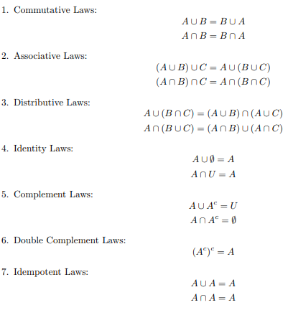

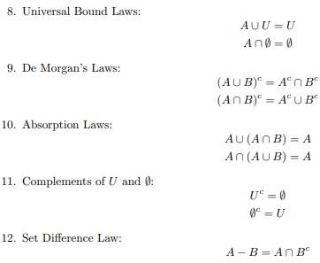

# Set Word Problem (Inclusive – Exclusive)

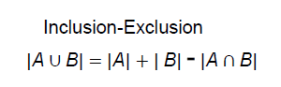

# Function

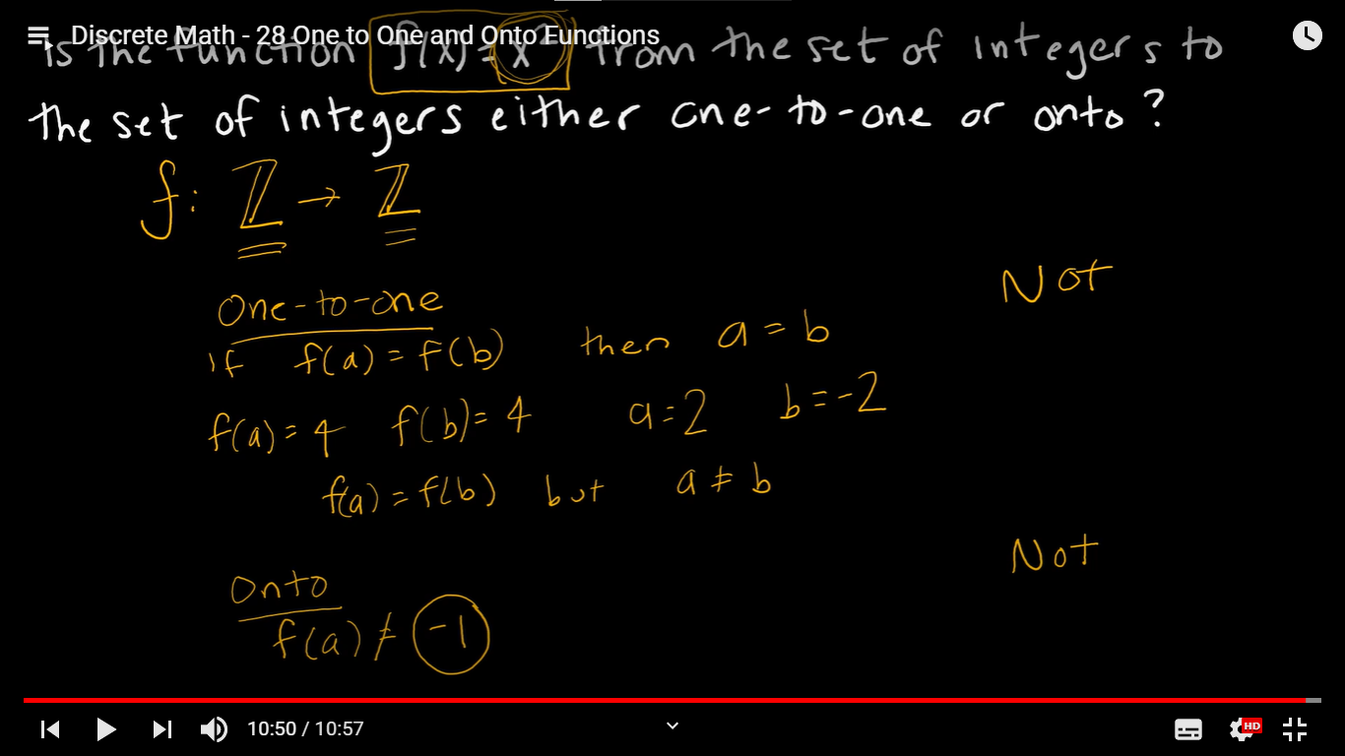

# Propositional Laws

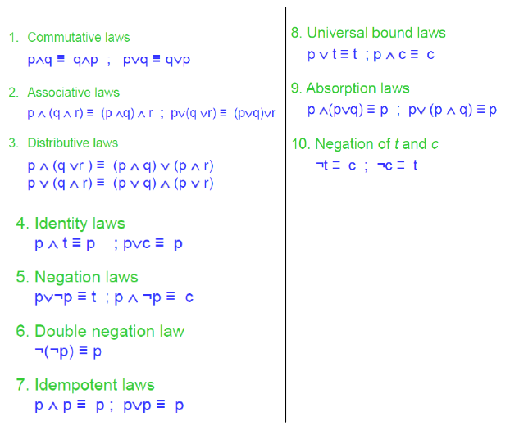

# Quantifiers

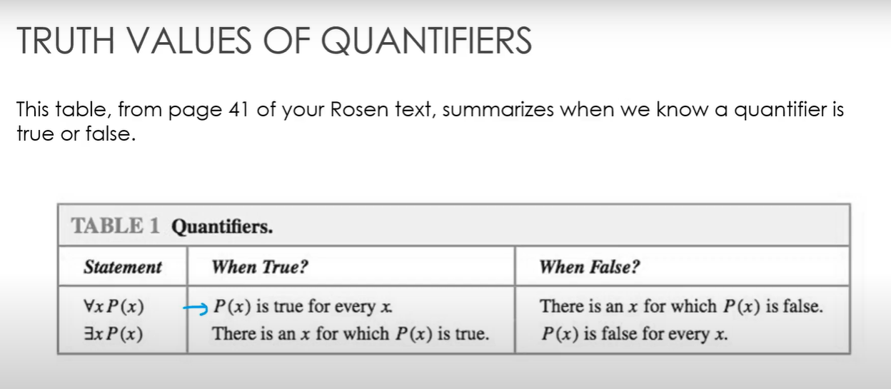





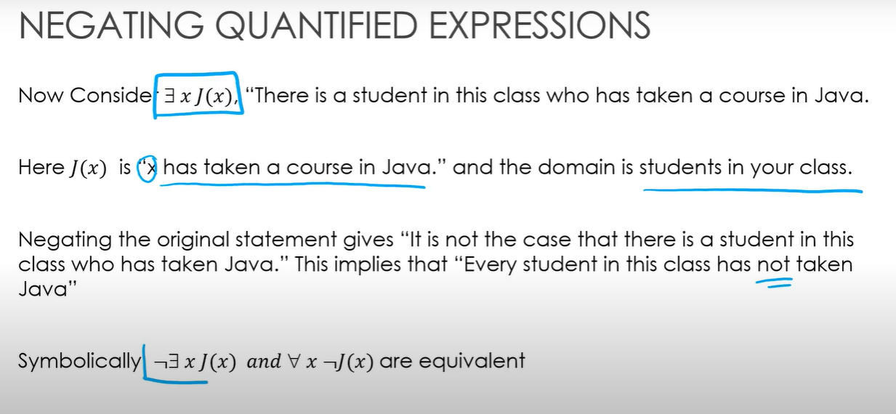



Practice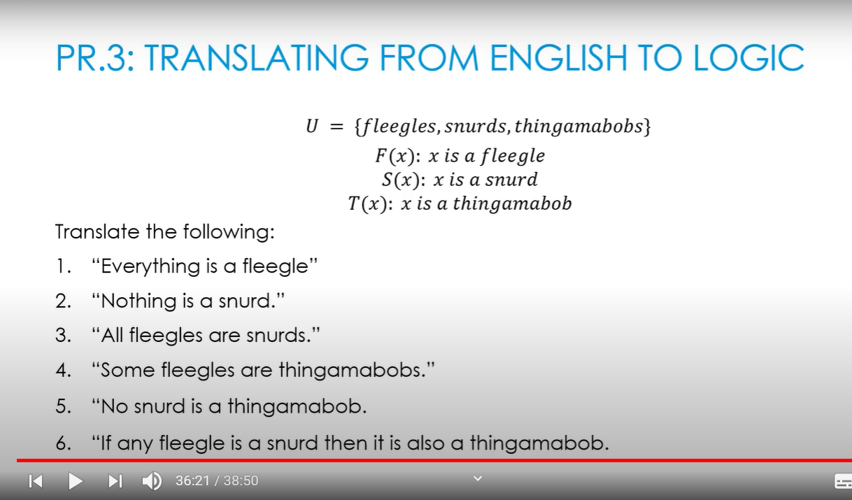

# Rules of Inference

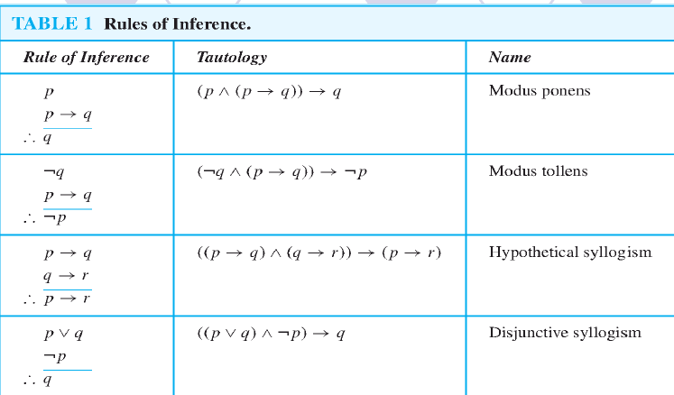

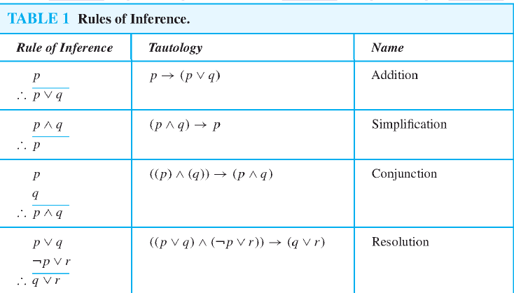

# Psuedorandom Numbers

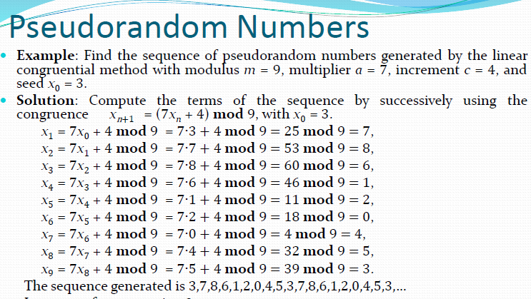

((a(xn) + c) mod m 🡪 Until the seed is repeated.

# UPCs

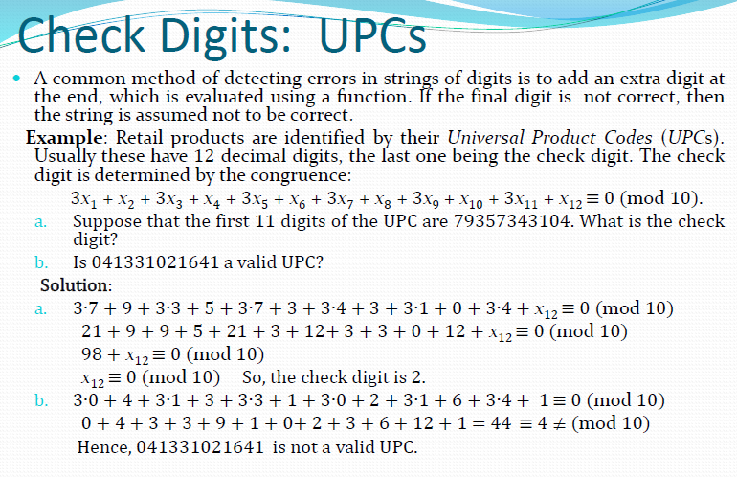

# ISBNs

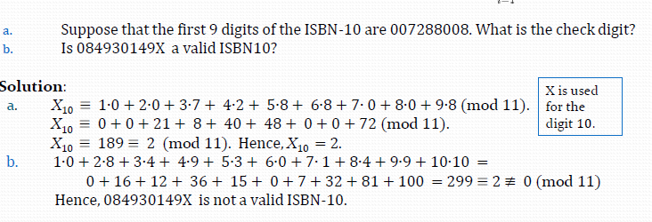

# Division Algorithm and Modular Arithmatic (Congruent)

a=qd+r

a=Number q=Divisor d=Quotient r=Remainder

**-112 is divided by 10?**

A=-112 q=10 d=-12 r=8

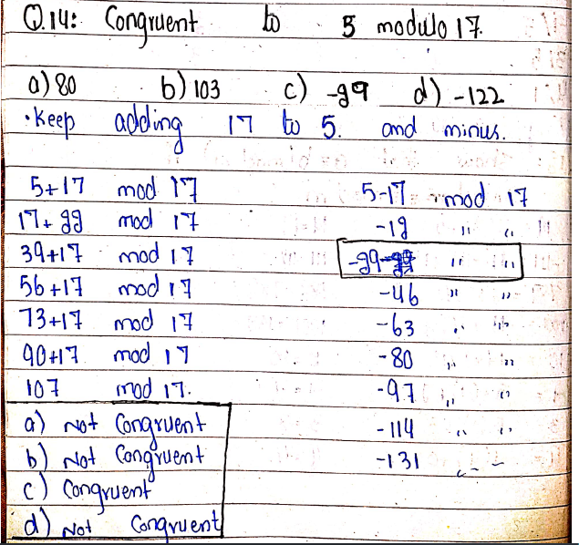

# GCD and LCM

GCD(16,32) 🡪 16=1,2,4,8,16 32=1,2,4,8,16,32 GCD = 16

24= 1,2,2,2,3 36= 1,2,2,3,3. GCD = 12 (2,2,3)

LCM(8,14) Multiple that occurs most of the time.

8 = 2,2,2 14 = 2, 7 LCM = 2,2,2,7 🡪 56 Answer

# Euclidean Algorithm

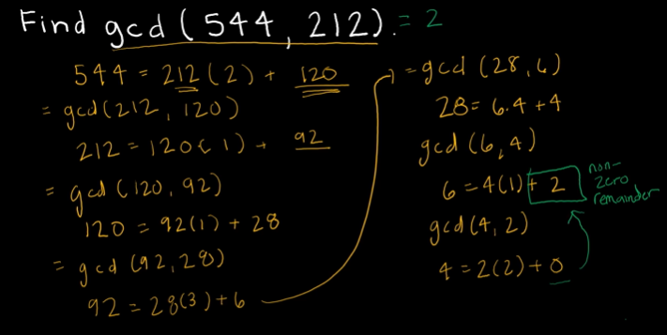Find (414,662)